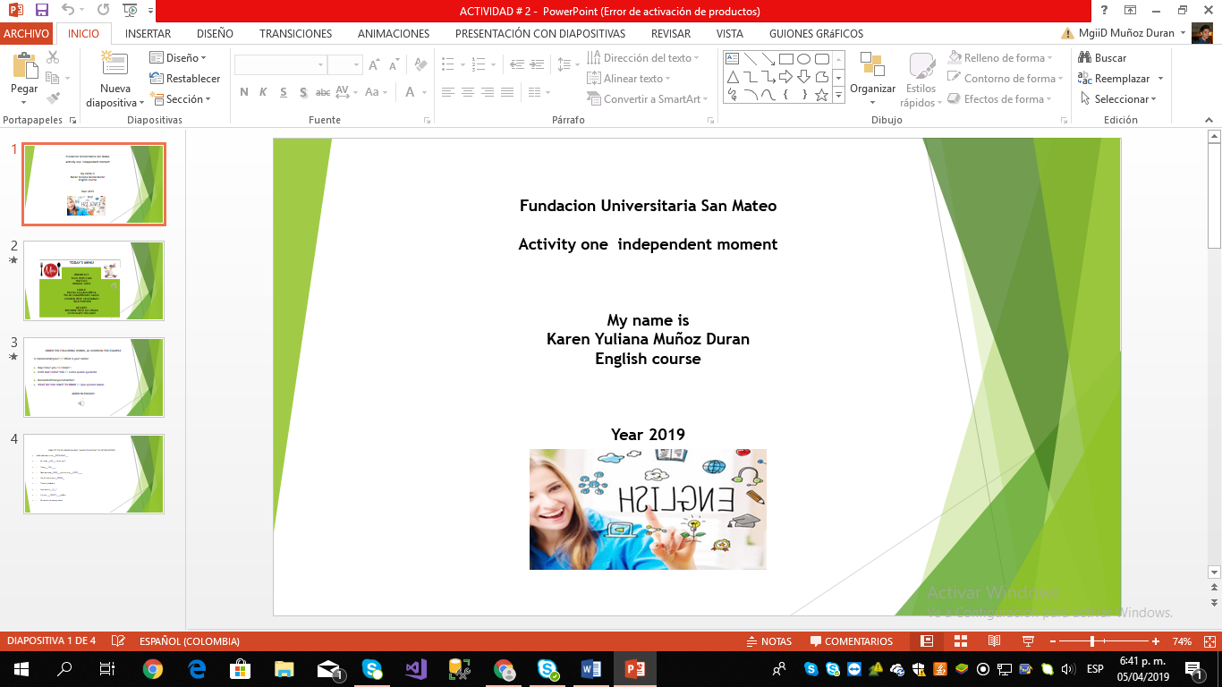

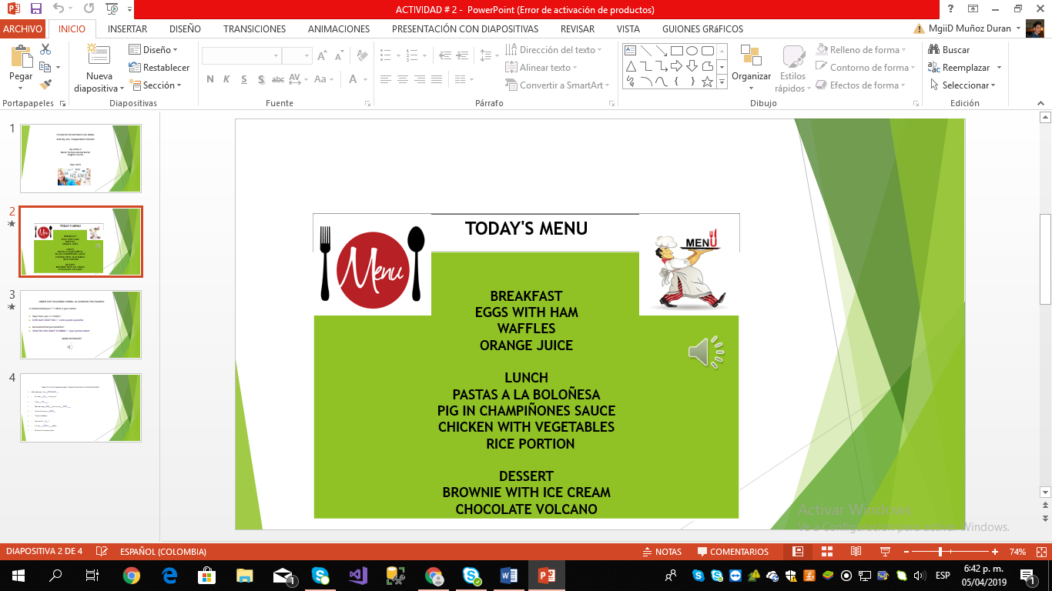

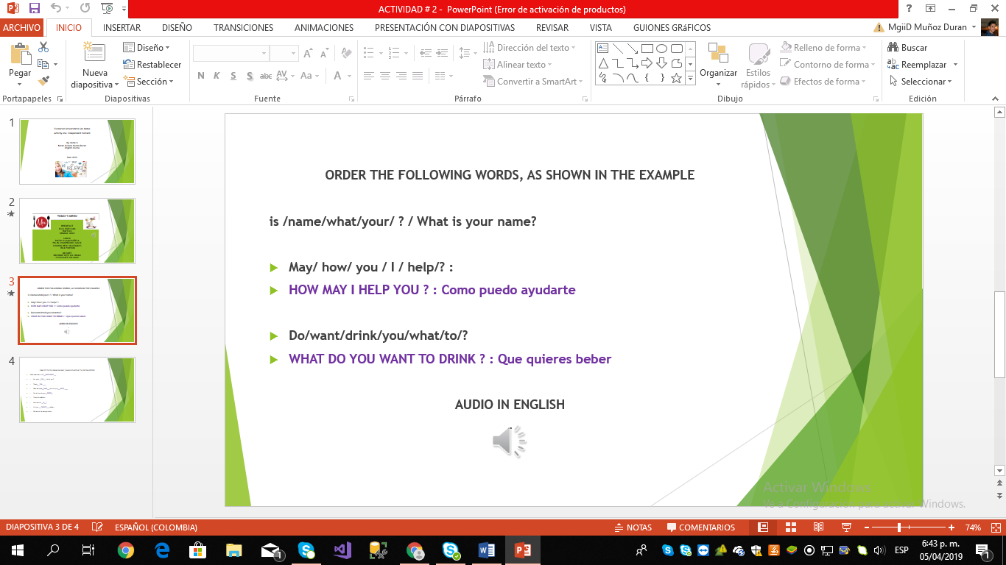

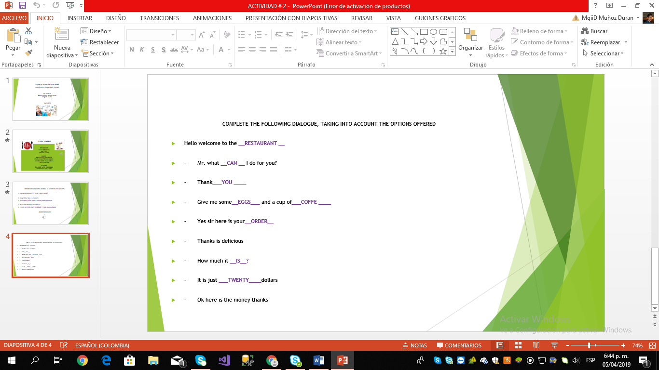

AUDIO ENGLISH

<https://drive.google.com/file/d/1XRLyqUjXf3HMMgO__HLMhjWJ-82DbNqa/view?usp=sharing>